Application for the post of PRT/TGT Maths/Science Teacher.
Resume

Name: Megha Bindal  - mail: meghabindal1986@gmail.com  Mob. No.: +919999068147  +917065466223 | 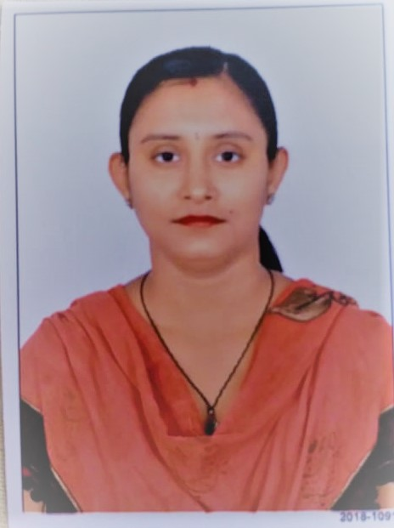

Career Objective:
To be associated with reputed organizations where I can utilize my skills and abilities and learn new things towards technology by working with them, which will offer me professional growth while being resourceful, innovative and flexible and make my career bright in the pool of competitions.
Academic Qualifications:
Year | Degree | University/Board | Aggregate Marks
2002 | X | I.C.S.E  (St. Anthony’s Junior College) | 60.33%
2005 | XII | C.B.S.E  (Agra Public School) | 57.6%
2011 | B.tech(I.T) | Uttar Pradesh Technical University(U.P.T.U) | 63.5%
2016 | M.B.A(I.T) | Symbiosis Centre For Distance Learning(S.C.D.L) | 71.0%
2018-2020 | B.Ed (Science,Maths) | Dr. B.R. Ambedkar University(D.B.R.A.U) | 65.4%

Professional Skills:
High Level Languages : C, C++, Java, HTML, Java Script
Operating System : Windows 98/2000/XP.

Projects:
Tenders Online : A project in .Net Technology (in B.Tech 6th sem)
Network Manager : A project in .Net Technology(in B.Tech 8th sem)

Job Profile:
- Worked in Holy Public School, Agra as Computer Teacher.
- Worked for 3 years in St. George’s College, Agra as Maths Teacher.
- Worked with Delhi Public Senior School, Gurgaon which is in collaboration with Teachlive4u as Science, Maths and Hindi Teacher?

Extra Curricular Achievements:
Positions of Responsibility: | - Coordinator in Alchemy 2009 event by B.M.A.S Engineering College.  - Volunteer in NATIONAL INTENSIVE PULSE POLIO IMMUNIZATION CAMPAIGN organized by City Health Ministry, Agra and S.N. Medical College, Agra.
Achievements: | - Awarded with certificate by CLHRD for attending “FEEL Employable” Learning and Development Intervention.  - Awarded with certificate for participating in Debugging, Logic Magic organized by B.M.A.S Engineering College.  - Awarded with Gold Medal in Throw-ball organized by St. Anthony’s Junior College.  - Awarded with certificate for participating in Marathon organized by St. Anthony’s Junior College.  - Awarded with Bronze Medal for securing highest marks in Sanskrit by St. Anthony’s Junior College.  - Awarded with Scholarship Certificate organized by LCC Infotech Ltd.  - Awarded with certificate for participating in NATIONAL LEVEL MATHEMATICS APTITUDE TEST organized by BRIGHT CAREER, ROHTAK.  - Awarded with certificate by Pepsi for participating in “WE ARE THE BEST, The Quiz Contest”.  - Awarded with certificate for participating in Ninth G.K. Competition organized by Academic Council for International Fraternity, Jaipur.  - Awarded with certificate for participating in National Science Olympiad 2002-03 organized by Mastermind Classes.

Strengths:
- Dedication to Work.
- Honesty.
- Good Communication Skills.
- Always dedicated on improving my Skills and Abilities and ready to learn new things.

Personal Details:
Nationality: | Indian
Temporary Address: | House No. 875, Sector 45, near Church of Immaculate  Conception, Gurugram, Haryana(122003)
Permanent Address: | 34 A, Double Story Flats, North Idgah Colony, near  Police Lines, Agra, Uttar Pradesh(282010)
Father’s Name: | Dr. Satendra Gupta
Marital Status | Married

I HEREBY DECLARE THAT ALL THE ABOVE MENTIONED INFORMATION IS CORRECT TO THE BEST OF MY KNOWLEDGE.

(Megha Bindal)
Date- 15/01/2021

